

SynapNet: AI-Powered Network Observability&Autonomous Operations
From reactive firefighting to autonomous, predictive networks

SynapNet transforms how organizations manage their network operations, leveraging advanced AI to create self-healing, autonomous networks that predict and resolve issues before they impact users

The Challenge with Today’s Network Operations
Modern networks have become increasingly complex, creating significant operational challenges:
Multi-Vendor Complexity
Networks require deep expertise across diverse vendor ecosystems, creating knowledge silos and integration hurdles
Alert Fatigue
Operations teams are overwhelmed with thousands of daily signals, making it difficult to identify critical issues
High Operational Costs
24×7 Network Operations Centers (NOCs) are expensive to staff and scale,
especially with skilled personnel shortages
Edge Location Challenges
Remote sites like ships, oil rigs, and rural ISPs suffer from unstable connectivity and limited local IT staff


70% of IT bu dget s are spent merely keeping systems operational, leaving little room for innovation

Current tools remain fundamentally r ea c t ive — problems are only addressed after they' ve already impacted users.

The Future: AI-Powered, Lights-Out NOC

The network operations landscape is undergoing a fundamental transformation, driven by advances in artificial intelligence and machine learning:

- AI/ML now enables truly predictive and self-healing networks, shifting the paradigm from manual firefighting to autonomous operations

- Industry leaders are embracing the " Lights-Out NOC" concept — minimal staff with AI
handling the majority of operational tasks

- The AIOps market has surpassed $10 billion and continues to grow at double-digit rates annually

- Edge-first deployments represent a massive untapped opportunity (ships, remote enterprises, ISPs)


$ 10B+
AIOps Market Size
70%
Cost Reduction
Potential operational savings through AI-powered automation

SynapNet: AI-Powered Unified Platform for Autonomous NetOps



Self-Learning Anomaly Detection
Continuously analyzes metrics, logs, flows,& telemetry to identify patterns&detect anomalies before they cause outages.
Predictive Intelligence
Forecasts link degradation and hardware failures, allowing preemptive action before issues impact users.


Auto-Remediation
Executes playbooks for common
incidents, with confidence scoring and
rollback capabilities for safety.
 Edge-First Design
Functions even when connectivity is intermittent, with offline capabilities crucial for remote locations.
Lights-Out NOC

Auto-resolution of 80%-90%of incidents with guardrails

 Lifecycle Automation
Manages EOL tracking, licensing, compliance, and vendor transitions automatically.


Role-Based Dashboards
Tailored views for operators, executives, and guests, showing exactly what each stakeholder needs.
Autonomous Provisioning& Migrations

Z ero-touch provisioning, intent-based configs.


" From data to decision to action — autonomously."

Why SynapNet is Different

Adaptive Intelligence
Self-learning models automatically adapt to each site' s unique traffic patterns and vendor devices, improving over time.
Multi-Source Correlation
Combines SNMP, syslog, NetFlow, RF telemetry, Prometheus, Configuration and even weather data to identify complex, interdependent issues.

Advanced Prediction

Anticipates issues like rain fade, congestion, or hardware failures befor e they impact service.

LLM-Powered Analysis
Large language models provide human-readable root cause analysis and remediation guidance.

Safe Automation
Confidence-scored remediation with built-in guardrails and rollback capabilities ensures operational safety.

Edge-First Design
Anomaly detection works offline at the edge, crucial for remote sites with unreliable connectivity.

SynapNet Architecture: AI-Powered NetOps Stack

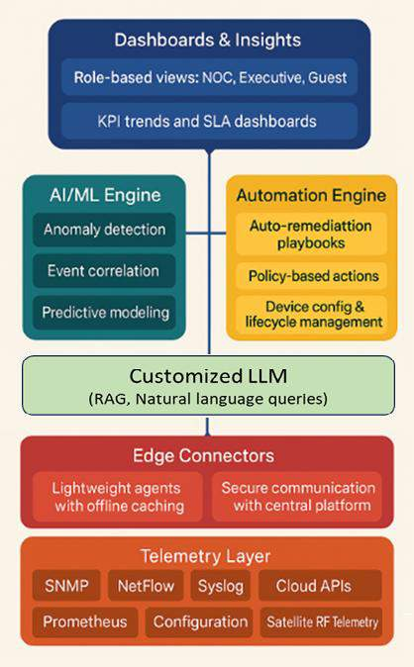
Data Collectors (Telemetry Layer)
Gather logs, metrics, SNMP traps, and telemetry from network infrastructure

AI Engine
Core ML/AI models perform anomaly detection, event correlation, root cause
analysis, and predictions
Automation Engine
Executes auto-remediation via playbooks, APIs, or scripts
Dashboards&Insights
Role-based dashboards for operations, executives, guests, and partners
Device and Asset Manager
Tracks licenses, EOL status, agreements, and configurations

and
Edge Connectors
Lightweight agents/gateways supporting offline operation with buffering real-time synchronization

This integrated stack creates a closed-loop system that continuously improves through operational feedback, making your network more
resilient and efficient over time

The SynapNet AI Advantage: From Detection → Prediction → Action → Verify:
SynapNet leverages a closed-loop AI system to transform network operations, moving beyond reactive fixes to proactive, autonomous management.









Detect: Anomaly Detection&Correlation
AI/ML models learn baselines and detect real-time anomalies from diverse data sources, correlating events into single, actionable incidents.

Verify: Closed-Loop Feedback
Monitors the impact of automated actions, continuously refining models and processes for improved reliability and efficiency.

SynapNet AI Loop
Predict: Analytics&Forecasting
Anticipates future failures, degradations, and capacity issues, providing proactive alerts before service
impact.

Act: Auto-Remediation&Autonomous Ops
Executes policy-driven actions and playbooks with confidence scoring, resolving 80-90%of incidents automatically.

Nois e → Signal:
Benefit s of t he Clos ed AI Loop:

50% fewer fa ls e pos it ives :

Shift fr om Rea c t ive t o Pr oa c t ive:

Collapse 100s of alerts into 1 enr ic hed inc ident

Au t onomou s O ps :
80–90%of incidents a u t o-r es olved

Relia b ilit y:
Confidence scoring + rollback ensures safe actions
less alert fatigue

70% fa s t er RCA:
fewer war rooms, faster recovery

O pt imizes c a pa c it y pla nning: avoids over/under provisioning
Predict and fix before outages

50% fa s t er MTTR
thanks to immediate AI-driven actions

Key Use Cases (Examples)

SynapNet' s AI capabilities unlock a range of critical applications, transforming reactive network management into a proactive and automated system.
Ra in Fa de & RF Degr a da t ion: Correlates SNR/EbN0 drops with external weather data.
CPU/Memor y Anomalies : Flags routers/switches against unique historical baselines.
Jit t er & La t enc y Anomalies : Identified in real- time within VoIP/video traffic.
Flow-Lev el Anomalies : Detects sudden DDoS traffic or persistent bandwidth hogs.
Mu lt i-Sou r c e Cor r ela t ion: Collapses SNMP, syslog, and NetFlow into one incident.
AI Log Pa r s ing: LLMs convert messy syslog
messages into structured anomaly events.
•

•

•

•

•

•
Self-Learning Anomaly Detection&Correlation
1
Link Degr a da t ion Pr edic t ion: Forecasts rain fade, dish misalignment, congestion buildup.
Ha r dwar e Fa ilu r e Pr edic t ion: Detects early signs in fans, power supplies, CPU thermal stress.
St or a ge & Dis k Wea r : Anticipates flash/disk wear- out in network/storage appliances.
Sea s ona l Demand For ec a s t ing: Predicts peak Wi-
Fi loads and holiday spikes.
Lic ens e & SSL Ex pir y For ec a s t : Provides AI reminders with auto-renewal workflows.
Ca pa c it y For ec a s t ing: Predicts when WAN links
will saturate, triggering upgrades or rerouting.
•

•

•

•

•

•
Predictive Analytics&Forecasting
2
Pr eempt ive QoS Thr ot t ling: Automatically deprioritizes non-critical traffic during predicted congestion.
Fa ilover O r c hes t r a t ion: Seamless VSAT → LEO
→ LTE → 5G switch with minimal disruption.
Int er fa c e Bou nc e / Ser vic e Res t a r t : Initiated when persistent errors are detected.
Config Rollba c k: Returns to golden baseline after drift or failed changes.
Dyna mic Rou t ing Adju s t ment s : BGP/OSPF weight tuning to meet SLA targets.
Au t oma t ed Pla yb ooks : E.g., “RF LOCK LOST” syslog event → satellite failover.
Sec u r it y Au t o-Ac t ions : Detects brute-force
logins, auto-blocks malicious IPs at ACL/firewall.
•

•

•

•

•

•

•
Auto-Remediation&Autonomous Ops
3

From Reactive NOC to Lights-Out NOC

Traditional NOC
- 24×7 staffing with specialized expertise
- Reactive problem-solving after impact
- 100+ Alerts
- Manual remediation processes
- Knowledge silos and inconsistent responses
- High operational costs that scale with
network size

SynapNet
AI Engine

SynapNet Lights-Out NOC








- Auto-resolves 80-90% of incidents without
human input
- Confidence scoring ensures safe automation
- Canary execution with automated rollback for risky changes
- Thin on-call layer only for novel or critical issues
- Consistent, documented remediation for all
incidents

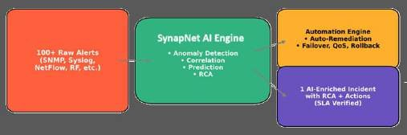
50%
MTTR Reduction
80%
Auto Resolve




70%
OpEx Savings

30%+
Uptime Improvement

Beyond Operations: Smart Lifecycle Management

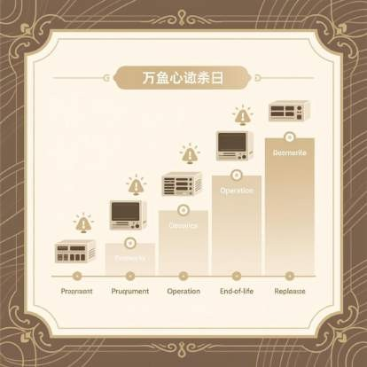
SynapNet extends beyond day-to-day operations to manage the entire lifecycle of your network infrastructure





EOL/EOS Tracking
Automatically identifies devices approaching end-of-life or end-of-support, recommending appropriate replacements based on your environment and requirements.

License&Compliance Automation
Monitors license expirations and compliance requirements, initiating proactive renewal workflows
with sufficient lead time for budgeting and approval.

Capacity Forecasting
Analyzes historical traffic patterns to predict future capacity needs, including seasonal peaks, allowing for planned scaling rather than emergency upgrades.

Audit-Ready Reporting
Generates comprehensive reports for executives and regulators, documenting compliance status, security posture, and operational performance.

managing the complete lifecycle, SynapNet eliminates surprises and creates a pr edic t a b le oper a t iona l envir onment with no unexpected hardware obsolescence or license expiration


Dashboards Tailored to Every Stakeholder
SynapNet recognizes that different roles require different perspectives on network health and performance. Our role- based dashboards deliver precisely what each stakeholder needs:
Operator View
Detailed technical dashboards showing:
•
•
•
•
•
Real-time telemetry and traffic patterns
Anomaly detection with highlighted deviations Root cause analysis insights
Active incident management
Historical trend analysis
Executive View
Business-focused dashboards featuring:
•
•
•
•
•
Uptime percentage and SLA compliance ROI reporting and cost savings metrics Strategic initiative tracking
Resource utilization and efficiency
Comparative benchmarks
Guest View
Simplified status indicators:
•
•
•
•
•
Internet: Stable / Degraded / Down Key application availability
Expected resolution timeframes
Basic self-service troubleshooting Subscription management

Each dashboard is carefully designed to provide actionable insights without overwhelming the user with unnecessary complexity.

Freedom from Vendor Lock-In


SynapNet liberates your organization from the constraints of single-vendor environments, providing seamless integration across your entire network ecosystem:
- Comprehensive support for all major network vendors including Cisco, Juniper, Huawei, Starlink, Inmarsat, AWS, and Azure
- AI-powered translation of configurations between different vendor platforms
- Automated validation for safer migrations with less risk
- Simplified transition from legacy brownfield deployments to modern intent-based networking

Our vendor-agnostic approach gives you the freedom to choose the right equipment for each use case without
sacrificing operational consistency or visibility.

"SynapNet transformed our multi-vendor environment from a management nightmare into a unified,

Z ero-Touch Deployment at Scale

AI-Driven Intent Templates
SynapNet revolutionizes device configuration through AI-powered intent translation:
- Express networking goals in plain language
- AI converts intent to vendor-specific configurations
- Templates adapt to site-specific requirements
- Continuous validation against best practices

Autonomous Provisioning
Deploy new network nodes with minimal human intervention:

- Z ero-touch provisioning from central management
- Automated device discovery and enrollment
- Secure configuration deployment
- AI-powered validation with rollback capability


This approach dramatically reduces deployment time while eliminating the configuration errors that commonly plague manual provisioning processes. A task that once
required hours of engineer time can now be completed in minutes with greater accuracy and consistency.

" Configure once, deploy everywhere, validate automatically."

Quantifiable Impact with SynapNet

SynapNet delivers measurable business value across multiple dimensions:

 Operational Cost Reduction
Reduce NOC staffing costs by 70-80% through intelligent automation, allowing
you to redirect resources to innovation rather than maintenance.

 Faster Issue Resolution
Improve Mean Time to Resolution (MTTR) by 50% through predictive alerts and autonomous remediation, minimizing service disruptions.

 Enhanced Network Reliability
Increase uptime by 30%+ with proactive maintenance and anomaly detection that identifies issues before they cause outages.

 Strategic Flexibility
Avoid vendor lock-in with multi-vendor migration capabilities, giving you freedom to choose best-of-breed solutions for each use case.

 Innovation Acceleration
Free engineers from routine firefighting to focus on strategic projects that drive business growth and competitive advantage.

Why SynapNet Wins Where Others Stop
The network operations landscape is filled with partial solutions that address only fragments of the overall challenge. SynapNet is the only platform that delivers a complete, end-to-end solution for autonomous network operations.

Capability | Datadog | Dynatrace | Moogsoft | SolarWinds | SynapNet





Advanced Observability





Predictive Analytics





Auto-Remediation





Edge-Ready Architecture




Multi-Vendor Support 

While others excel in specialized areas, only SynapNet delivers the c omplet e pa c ka ge of predictive intelligence, autonomous operations, edge-first design, and multi- vendor support necessary for true network transformation.
SynapNet isn' t just incrementally better—it represents an entirely new paradigm for network operations that aligns with the future of enterprise networking.

